SMART WASTE MANAGEMENT FOR METROPOLITAN CITIES (TEAM ID : PNT2022TMID42931)

**PERFORMANCE TESTING**

**NFT RISK ASSESSMENT**

|  |  |  |  |  |  |  |  |  |  |
| --- | --- | --- | --- | --- | --- | --- | --- | --- | --- |
| **S.N0** | **PROJECT**  **NAME** | **SCOPE/ FEATURE** | **FUNCTIONAL CHANGES** | **HARDWARE CHANGES** | **SOFTWARE CHANGES** | **IMPACT OF DOWNTIME** | **LOAD/**  **VOLUME**  **CHANGES** | **RISK SCORE** | **JUSTIFICATION** |
| 1. | Smart waste management | Existing | No changes | No Changes | No changes | No | No changes | Green | As We Have Seen No Changes |

**NFT DETAILED TEST PLAN**

|  |  |  |  |  |
| --- | --- | --- | --- | --- |
| **S.NO** | **PROJECT OVERVIEW** | **NFT TEST APPROACH** | **ASSUMPTION / DEPENDENCIES**  **/ RISK** | **APPROVALS/ SIGN OFF** |
| 1. | Smart Waste Management | Load Testing | No Risk | Approved |

**TEST RESULT**



**TEST RESULT IN GRAPH**

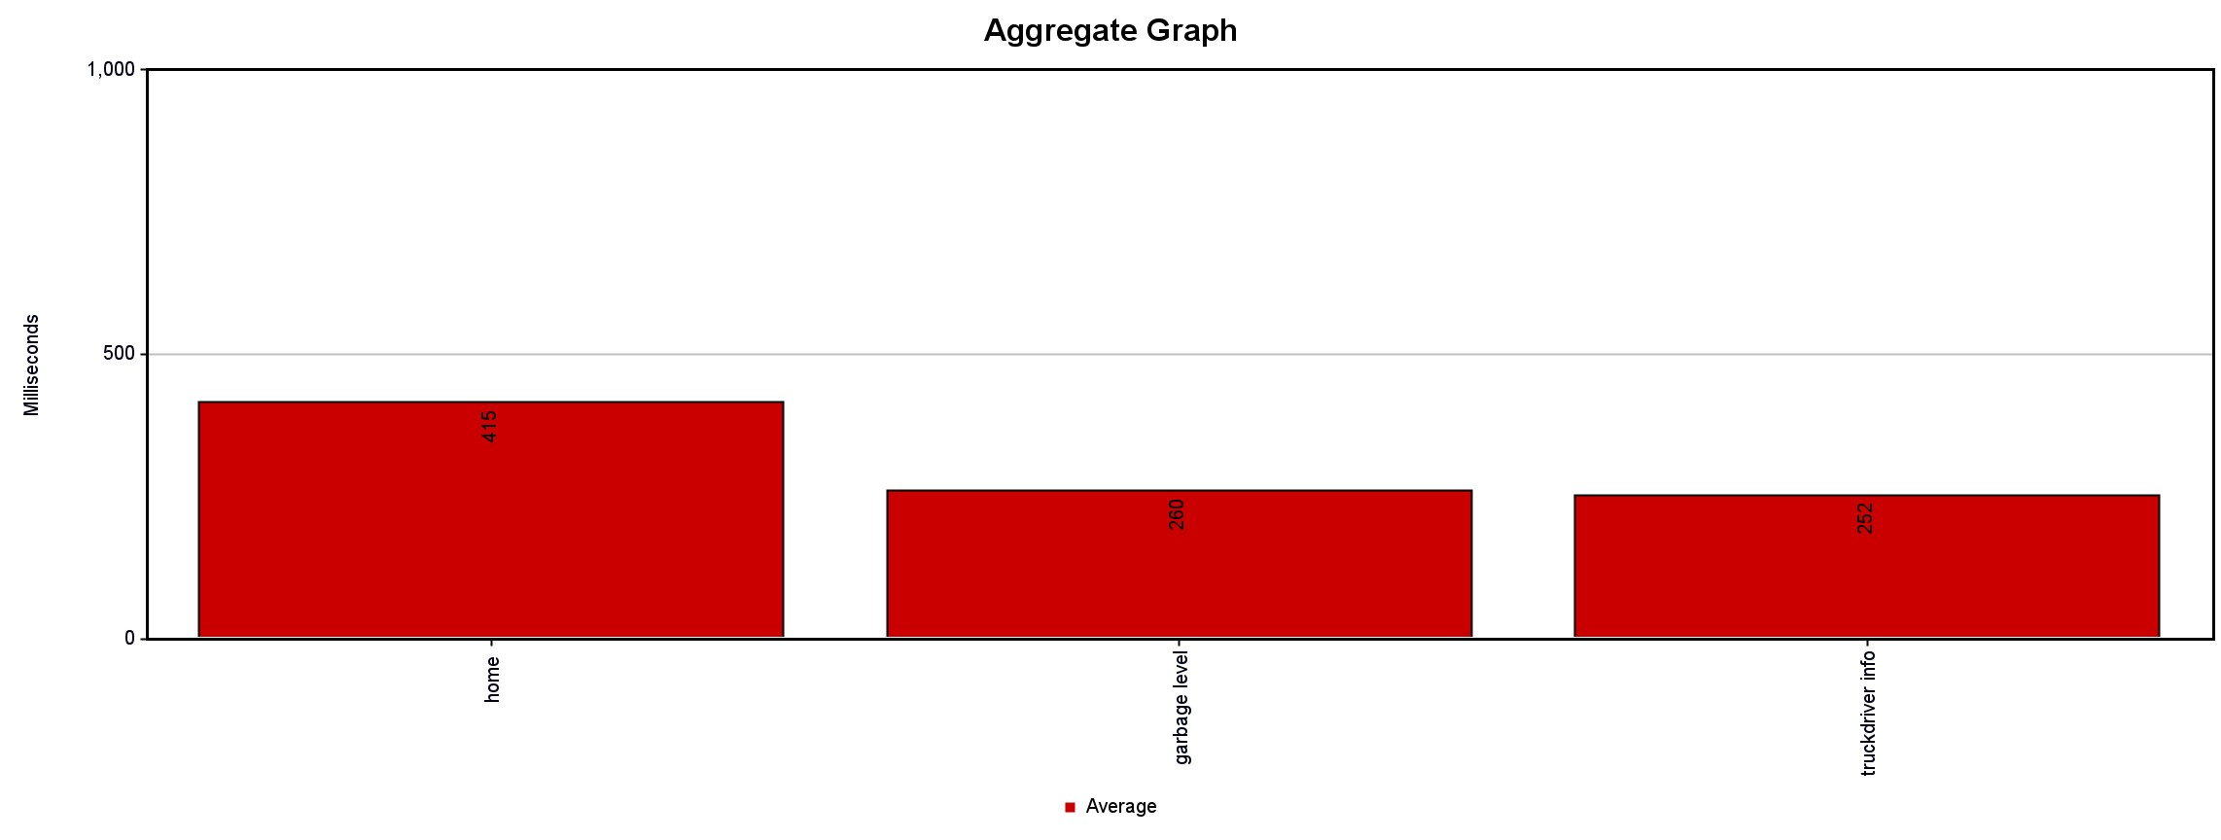

**END OF TEST REPORT**

|  |  |  |  |  |  |  |  |  |
| --- | --- | --- | --- | --- | --- | --- | --- | --- |
| **S.NO** | **PROJECT OVERVIEW** | **NFT TEST**  **APPROACH** | **NFR MET** | **TEST**  **OUTCOME** | **GO/ N0- GO DECISION** | **RECOMMENDATIONS** | **IDENTIFY DEFECTS** | **APPROVAL/ SIGN OFF** |
| 1. | Smart Waste Management | Load Testing | Yes | Success | Go  As We Found Zero Error In Test | Customer Can Access  This Website With Less Delay | No Defects | Approved |